**Data-Driven Decision Making.**

An analysis to identify the location for an Indian grocery store in Shoreview, Minnesota.

by Reghu Neelakantan

Abstract

This document details a consulting project where I am identifying the need and feasibility of an Indian grocery store in Shoreview, Minnesota.

Table of contents

1. Introduction
2. Data
3. Methodology
4. Results
5. Discussion
6. Conclusion
   1. **Introduction.**

I lived in Shoreview, Minnesota for about 4 years starting 2015. Being of Indian origin, I did not look forward to the 30 to 40 minute bi-weekly drive out of the city to buy groceries. Granted there were the regular chain groceries close by, like Cub Foods & Target but you could not find the specific Indian spices like cardamom or cumin seeds or mustard seeds that are used in every Indian cooking or the flour used to make the Indian bread also know as ‘roti’ or vegetables particular to Indian cuisine like okra or bitter gourd or drumstick. So, I felt that there was a need for an Indian grocery store close by to Shoreview, Minnesota. Especially, more so, considering the burgeoning Indian population there.

* 1. **Data.**

I wanted to identify the stores of Indian origin in the vicinity of Shoreview, Minnesota. That could give me the number of stores of Indian origin that are close by and help confirm that there was indeed a need for an Indian grocery store close to Shoreview.

I wanted to use data about all stores in the neighborhood of Shoreview with the facility name, address, longitude, latitude and category. I identified that Foursquare could be a trustworthy source for this information. To give a brief background about Foursquare:

Foursquare City Guide is a free location discovery app for iOS and Android. You can use it to find new places around you to visit based on searches or personalized recommendations given to you by the app.

**How the Foursquare City Guide App Works**

The Foursquare City Guide uses your device's GPS to identify your location and find places nearby that it can suggest to you. The more you use the app, the more it learns about the places you like to go so that it can recommend more places you'll probably love too.

Recommendations are crowdsourced from Foursquare City Guide users just like you who've been to those places and have left good ratings and reviews. Similar to other location discovery apps like Yelp, OpenTable, and others, Foursquare's recommendations are brought to you by its very own community. (Moreau, Elise April 04,2019)

* 1. **Methodology**

Having lived in Shoreview, Minnesota for about 4 years I had explored the area and knew the area well. And having searched physically and online, had arrived at an Indian store that was the closest to me and it was about 30 minutes when there was no traffic and up to an hour when the traffic was grid locked on week days. I wanted to identify a location where an Indian store. I used the data from the Foursquare API to pull in information from within 500 meters and 30,000 meters where the categories or name had the word ‘Indian’ in them.

* 1. **Results**

The data from the search results within 500 meters with the word ‘Indian’ in either the name or category, resulted in no results at all. I tried running the query in increasing multiples of 500 meters each with no result until I reached 30,000 meters. Now, 30,000 meters is 18 miles which is huge. There was no result to the query, to any place with ‘Indian’ either their name or category until I hit 30,000 meters.

We see when we plot the longitude and latitude of the coordinates from the search results that none of the blue circles are close by to the red circle that is the city of Shoreview, Minnesota.

And when we look at the results of the dataframe there is no Indian store. We see a few Indian restaurants but no Indian stores. The red circle in the screen shot below is Shoreview, Minnesota and the blue circles are the other stores. None of them are stores of Indian origin.

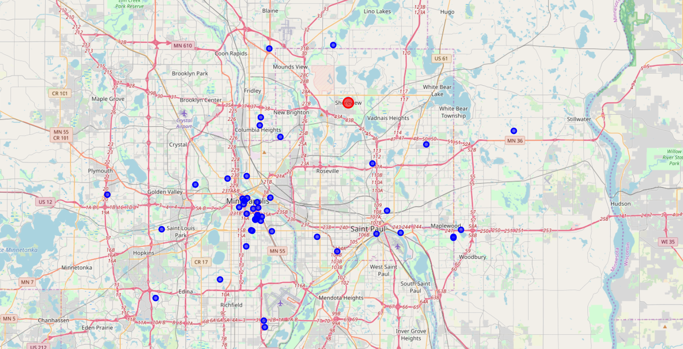

* 1. Once we look at the results of the search results and the search results plotted on a map, we can see that there are only Indian restaurants in the vicinity of Shoreview, Minnesota. And a review of the data frame results shows that the only categories with ‘Indian’ in them are Indian restaurants and no Indian stores.
  2. After reviewing the search results plotted on the map and actually viewing the data frame contents, we can arrive at the conclusion that there is huge potential demand for Indian stores in Shoreview, Minnesota. I personally, like many of my other Indian brethren could like to be able to get groceries of Indian origin closer to home. So, I could say there is a huge demand for Indian grocery stores in Shoreview, Minnesota.

References

<https://www.lifewire.com/foursquare-app-4590138> by (Moreau, Elise April 04,2019)